3. Explore with Wireshark/TCP-dump/cisco packet tracer tools and learn about packets filters.

Capturing packets in Wireshark:

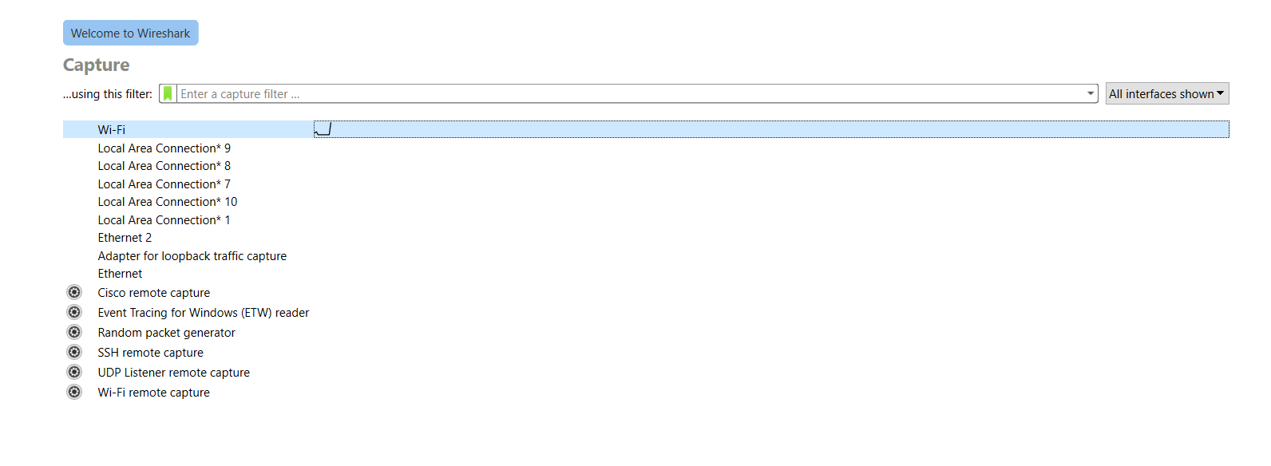

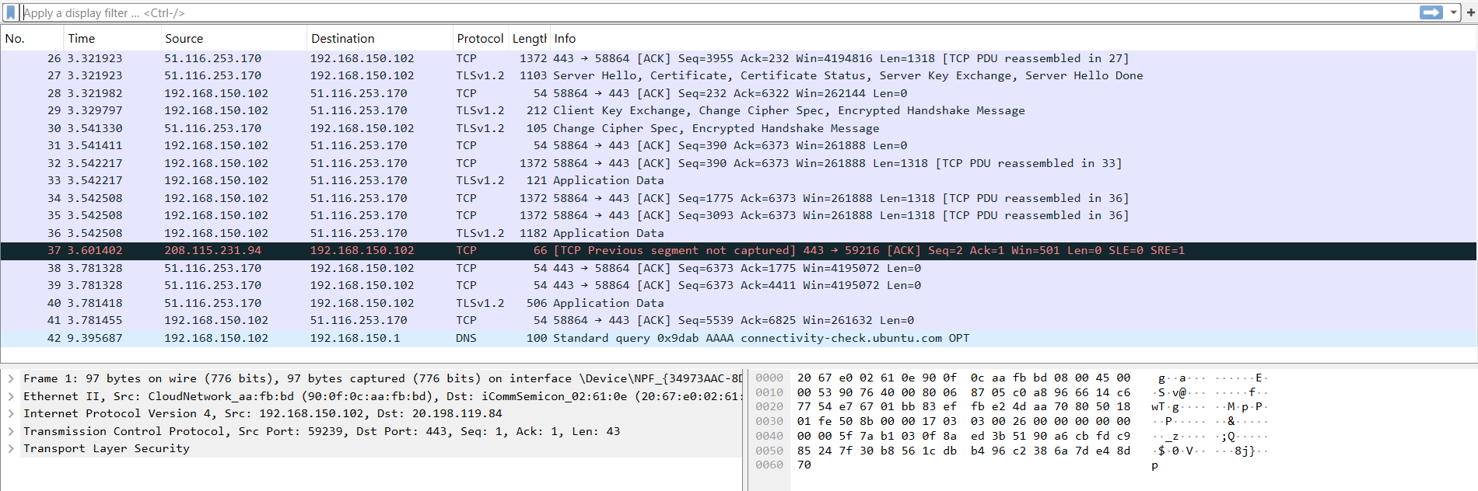

Filtering icmp packets from [www.wikipedia.org](http://www.wikipedia.org):

**icmp and ip.addr==103.102.166.224**

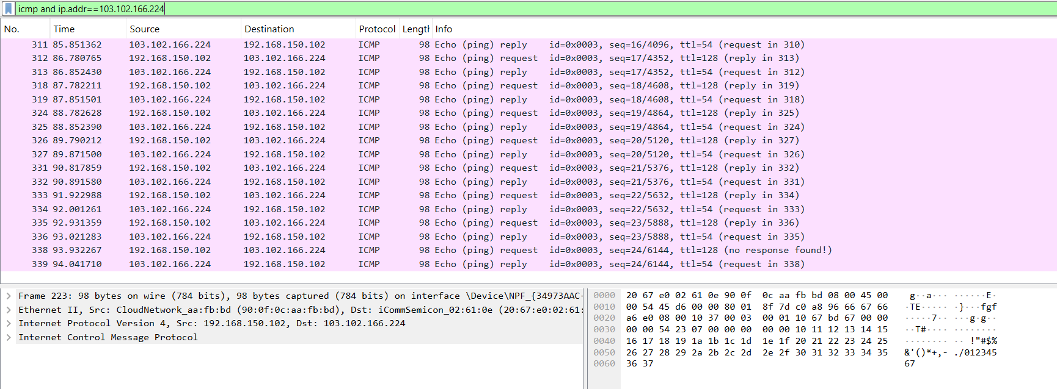

Filtering tcp packets on interface enp0s3 using tcpdump:

**sudo tcpdump -i enp0s3 tcp**

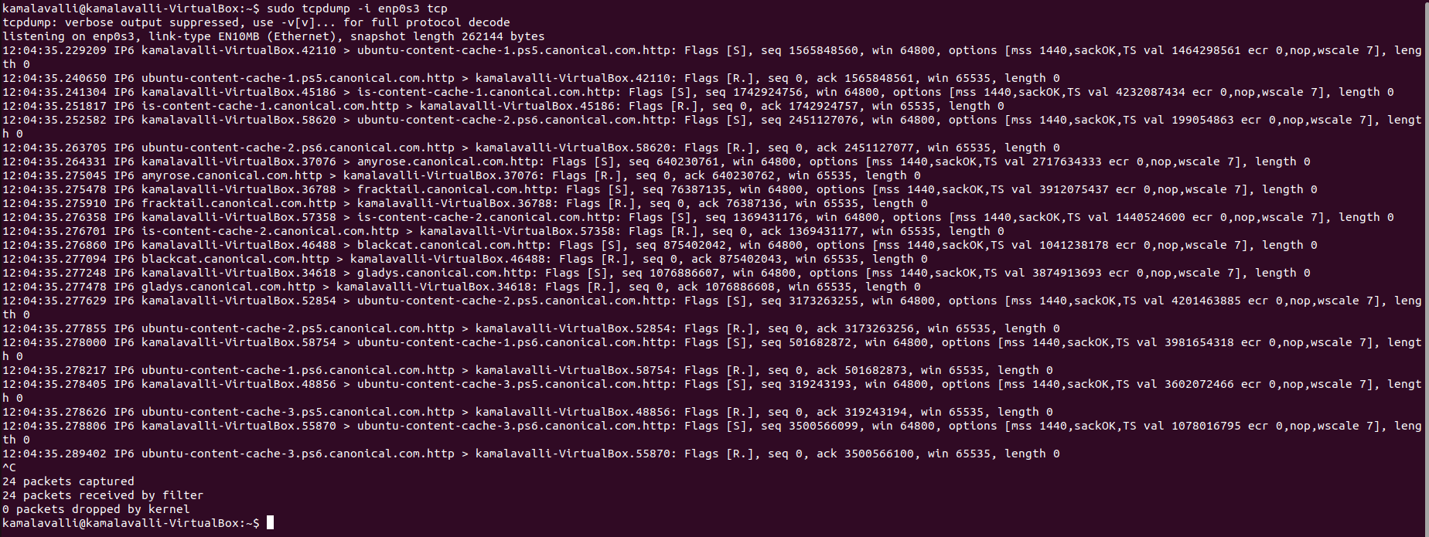

Saving packets in a file

**sudo tcpdump -i enp0s3 tcp -w capture.pcap**

